THE BOARD OF DIRECTORS OF THE SETTLERS PAK HOMEOWNERS' ASSOCIATION HELD THEIR MONTHLY MEETING AT THE SETTLERS PARK CLUBHOUSE ON THURSDAY, March 16, 2023, at 7:00 PM IN SUGARLAND, TEXAS.
DIRECTORS PRESENT: Bill Sargant, Diane Johnston, and Mike Reichek. Clinton Seay was present for Creative Management
CALL TO ORDER
Clinton Seay called the meeting to order and noted there was a quorum of Directors present
SUMMARY OF EXECUTIVE BOARD SESSION:
5 waiver requests were reviewed, 1 was granted waivers based on how much they owed, 1 was granted a one-time waiver, 1 was denied, 2 were granted waivers of late fees only.
APPROVAL OF MINUTES: the meeting minutes were approved
FINANCIAL REPORT: Treasurer Mike Reichek was at the meeting and reported that the invested money is currently down 3%. It was asked of Management, what percent of the insured funds policy is being utilized.
Delinquency Report — was reviewed
Presidents Update: The insurance was renewed for another year at an increased rate due to increased coverage amounts

COMMITTEE REPORTS
Social — In development, noted that the community budgeted $2,400 for 2023 Pool — Nothing new to report
Landscape — Discussion was had if the new social committee should handle the Yard of the Month
Website and Communications — Management was asked to touch base with a local college to see if a student could do the programming for us

UNFINISHED BUSINESS
BRICK WALL — Copies of the letters are being sent to the whole Board No Dumping Signs — Done
OPEN FORUM — There were several home owners in attendance with various questions about the community and how 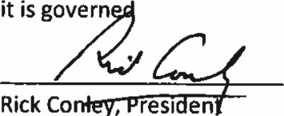it is govern
co
resi
en

